Exp.No-12
12. Perform Perspective Transformation on the image.

Aim
To perform perspective transformation on an image using OpenCV.
Procedure
- Start the program.
- Import the required libraries (cv2 and numpy).
- Read the input image (puppy.jpg).
- Define four source points on the image.
- Define four destination points.
- Calculate the perspective transformation matrix.
- Apply the perspective transformation to the image.
- Display the original and transformed images.
- Save the transformed image.
- Stop the program.
Program: 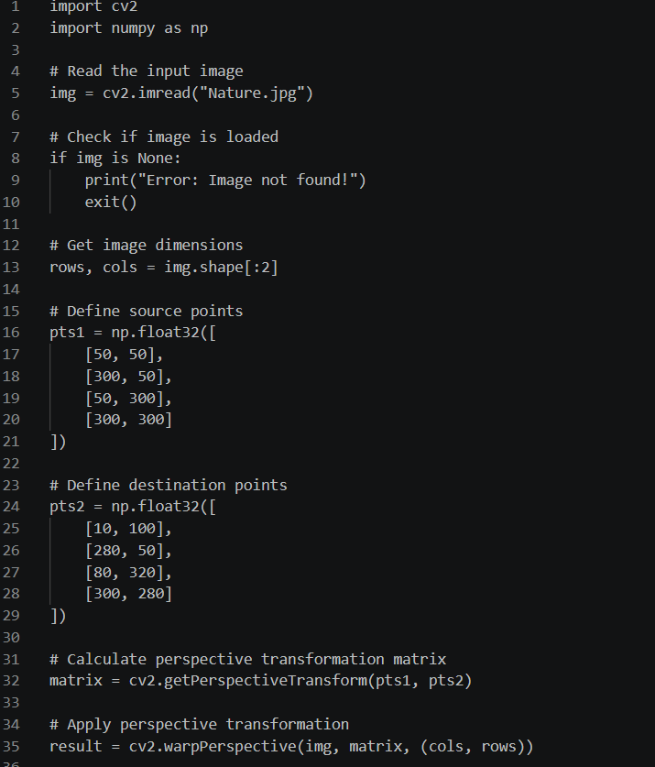
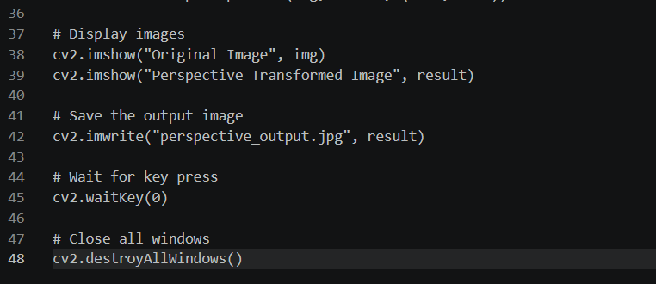
Input:

Output:
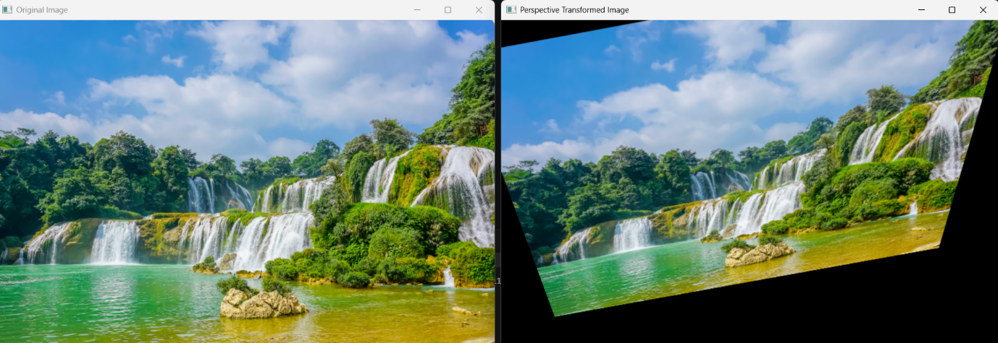
Result:
The perspective transformation was successfully applied to each frame of the input video using OpenCV. The transformed video was displayed successfully.

